Numl university Hyderabad



ASSIGNMENT #2

**Submitted by :- Khadija Abbasi**

**Class :- BSCS-III**

**Subject :- Digital Logic Design**

**Submitted to :- Sir Rafay**

**Date :- 14-Mar-2023**

**Session :- 2023**

PRACTICAL # 2:

Q:1 Verify following Rules of Boolean Algebra by designing them using Circuit Makers.

* 1. **Identity Law**

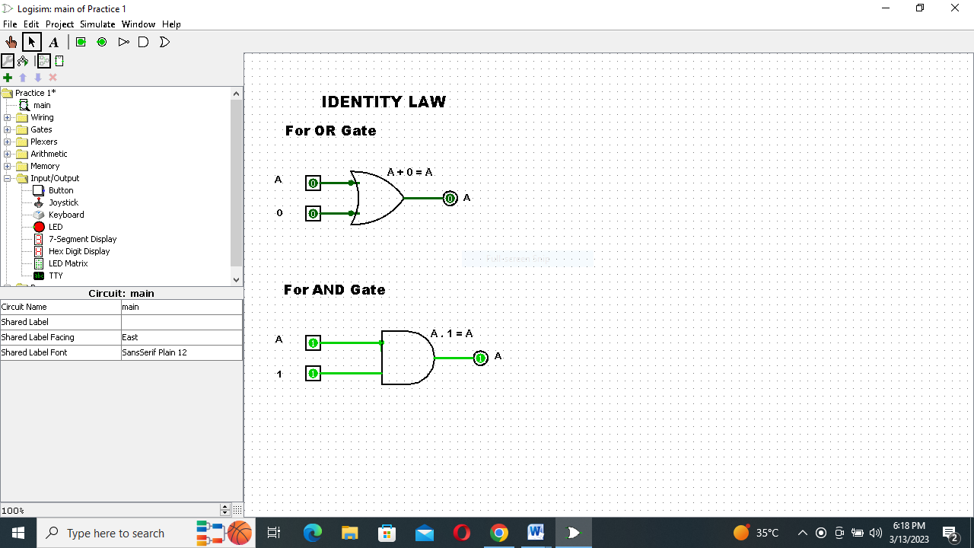

* 1. **Idempotent Law**

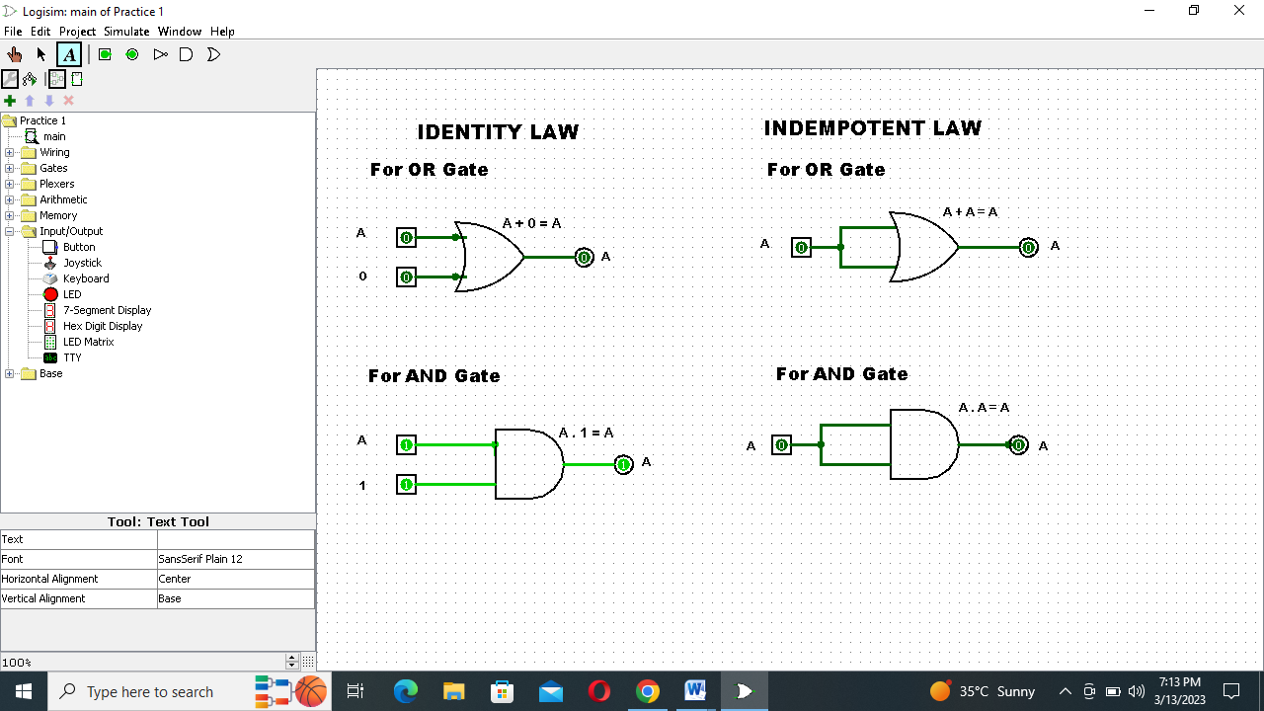

* 1. **Complement.**

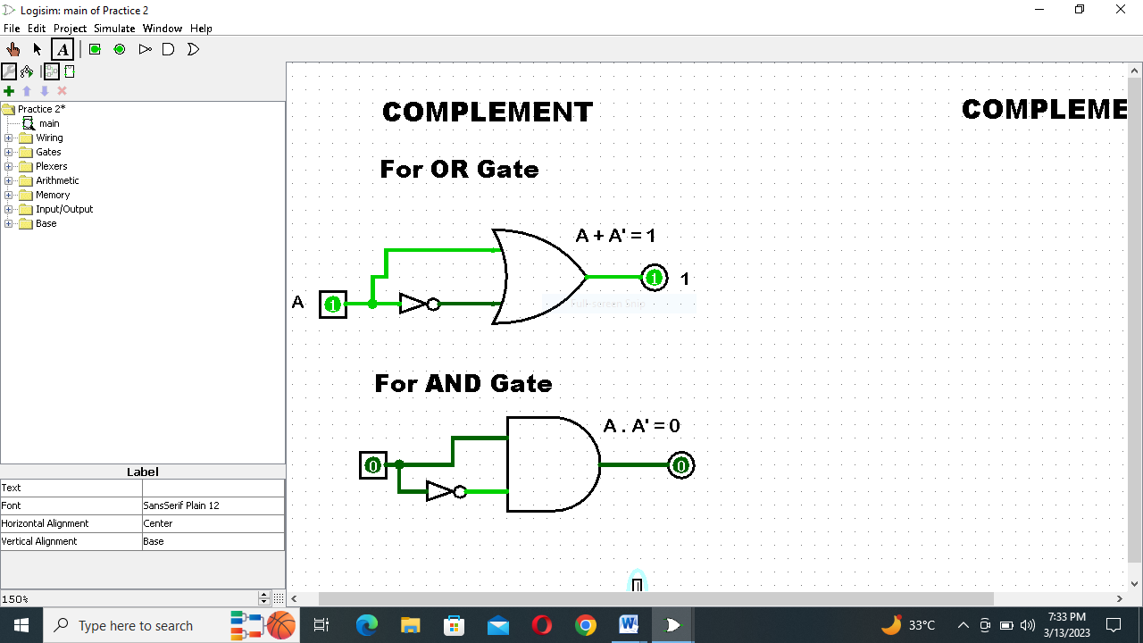

* 1. **Involution Law**

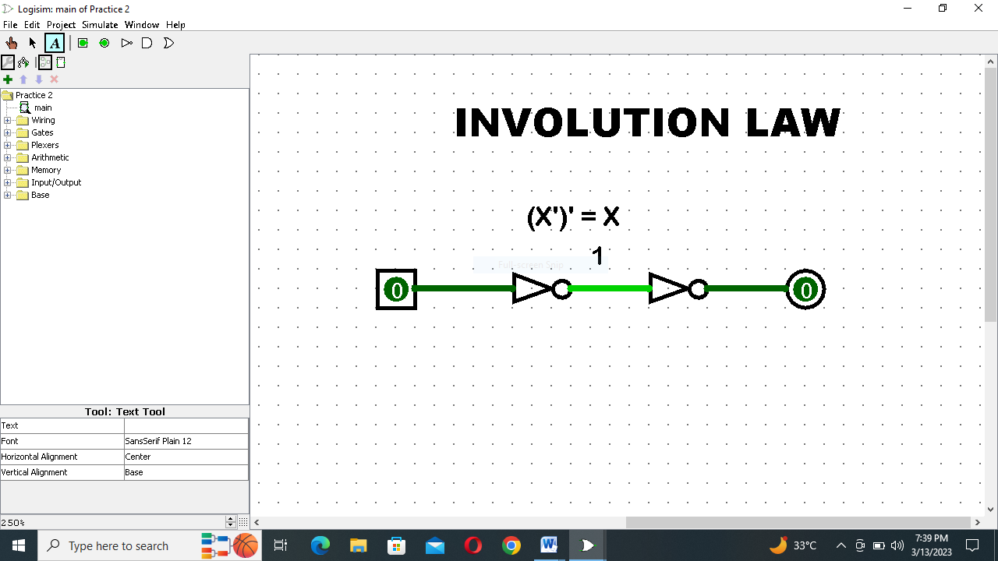

* 1. **Commutative Laws**

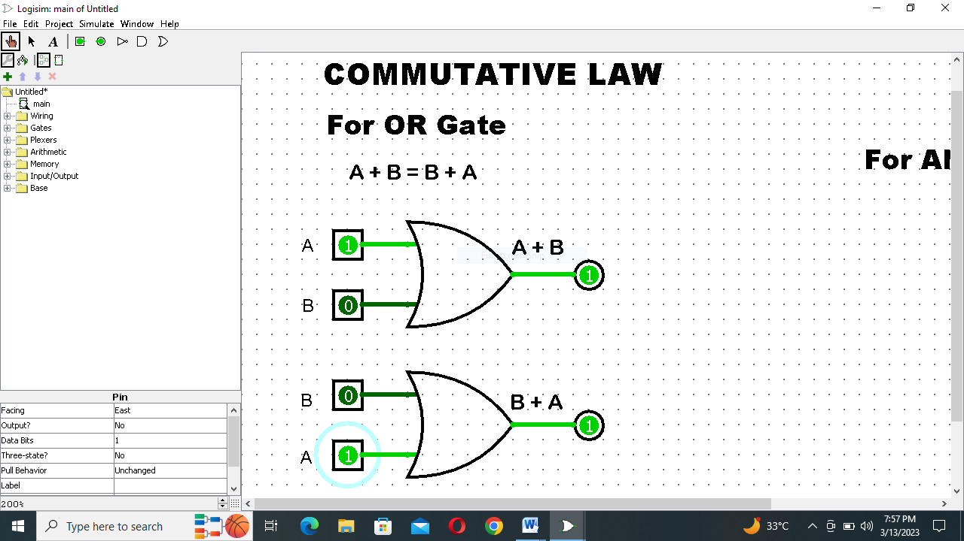

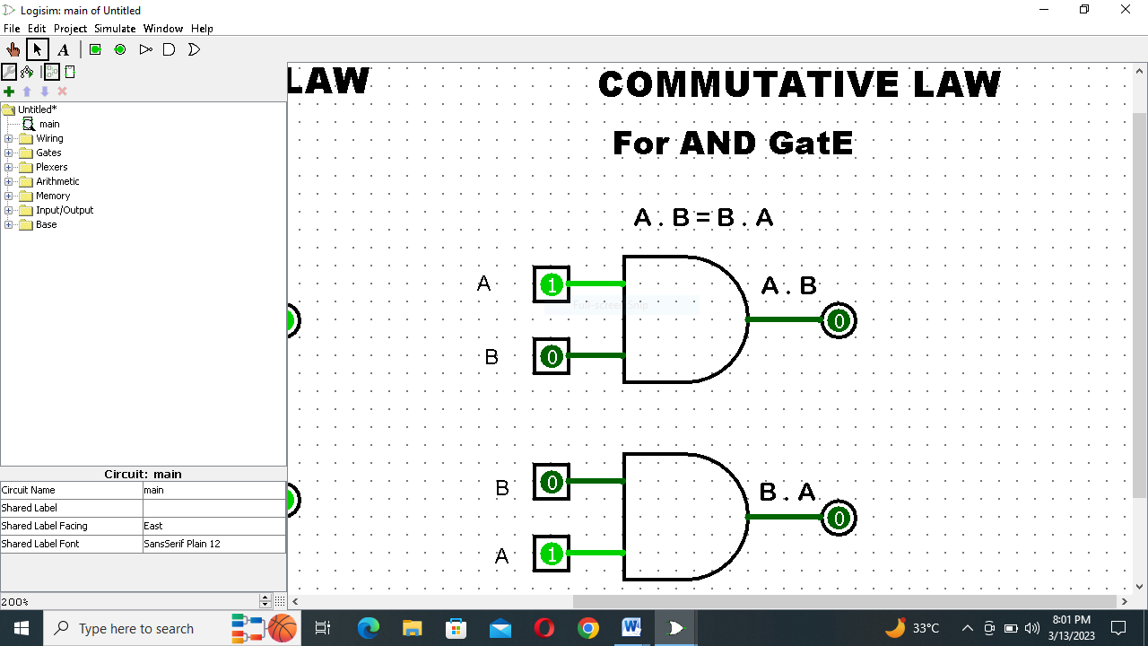

* 1. **Associative Law**

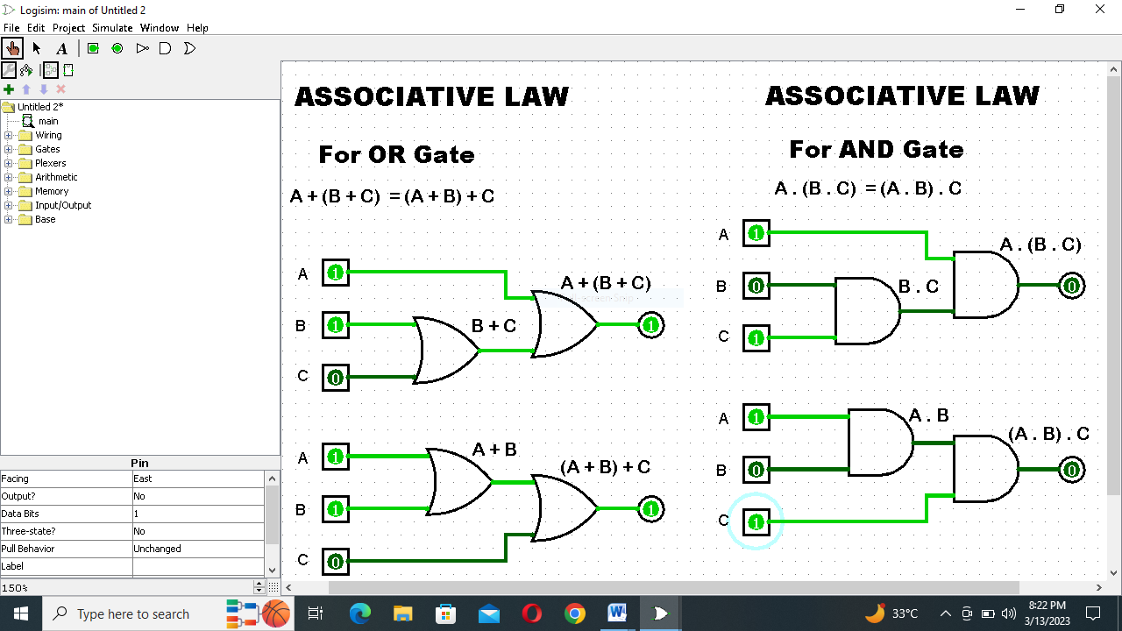

* 1. **Distributive Law**

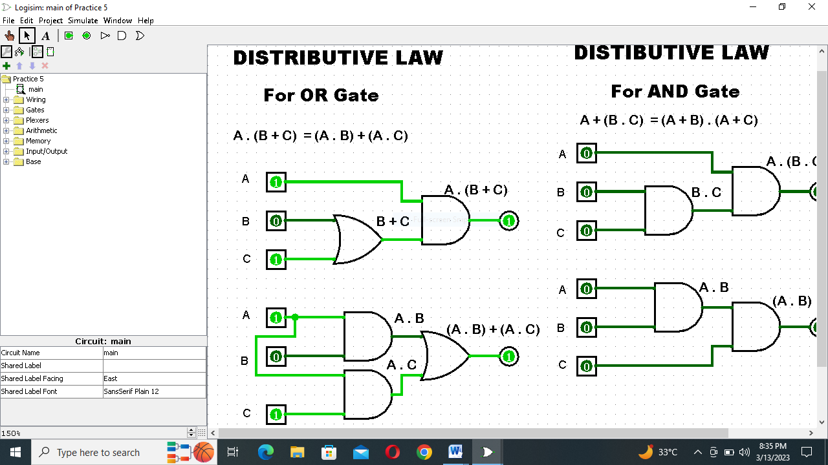

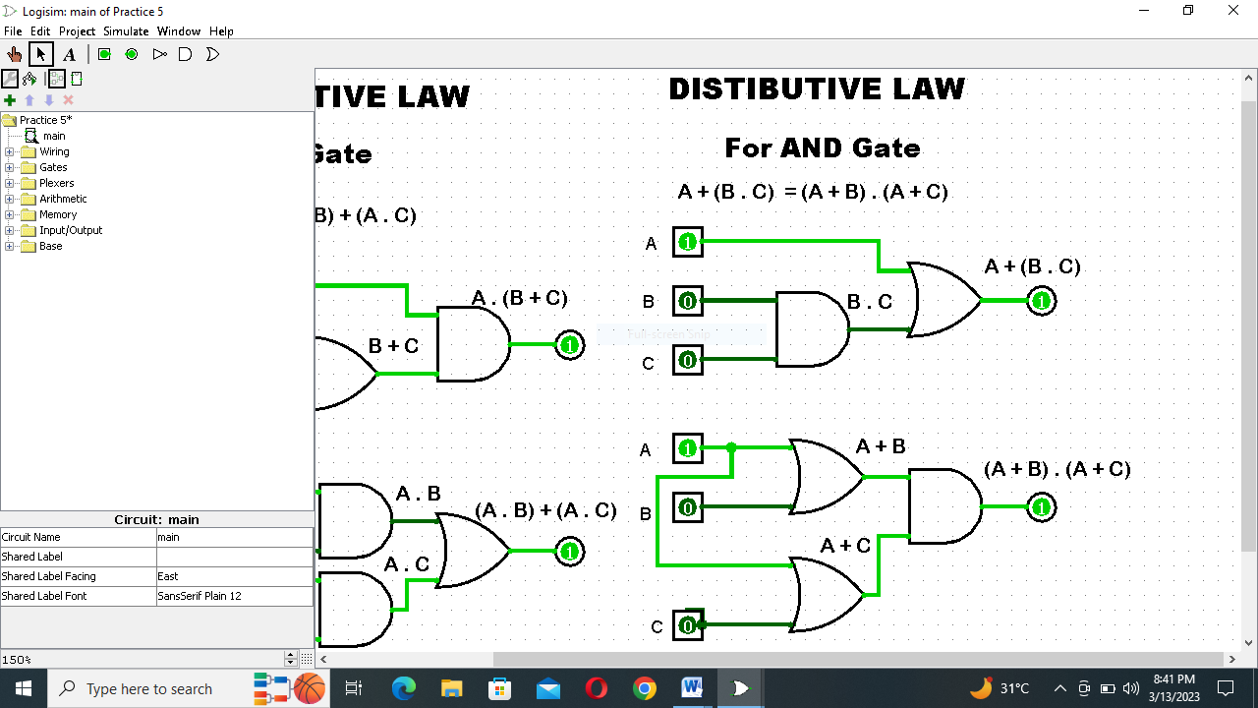

**Q:2 Simplify the expressions.**

1. F=(A+(BC)’)’

Solution:

F=(A+(BC)’)’ Using De-morgans law

F=A’ . ((BC’)’)’ Using Compliment law

:- (A’)’=A

F=A’ BC.

**For Verification:**

|  |  |  |  |  |  |  |
| --- | --- | --- | --- | --- | --- | --- |
| **A** | **B** | **C** | **BC** | **(BC)’** | **A+(BC)’** | **(A+(BC)’)’** |
| **0** | **0** | **0** | **0** | **1** | **1** | **0** |
| **0** | **0** | **1** | **0** | **1** | **1** | **0** |
| **0** | **1** | **0** | **0** | **1** | **1** | **0** |
| **0** | **1** | **1** | **1** | **0** | **0** | **1** |
| **1** | **0** | **0** | **0** | **1** | **1** | **0** |
| **1** | **0** | **1** | **0** | **1** | **1** | **0** |
| **1** | **1** | **0** | **0** | **1** | **1** | **0** |
| **1** | **1** | **1** | **1** | **0** | **1** | **0** |

|  |  |  |  |  |  |
| --- | --- | --- | --- | --- | --- |
| **A** | **B** | **C** | **A’** | **(BC)** | **A’(BC)** |
| **0** | **0** | **0** | **1** | **0** | **0** |
| **0** | **0** | **1** | **1** | **0** | **0** |
| **0** | **1** | **0** | **1** | **0** | **0** |
| **0** | **1** | **1** | **1** | **1** | **1** |
| **1** | **0** | **0** | **0** | **0** | **0** |
| **1** | **0** | **1** | **0** | **0** | **0** |
| **1** | **1** | **0** | **0** | **0** | **0** |
| **1** | **1** | **1** | **0** | **1** | **0** |

1. **F=(AB+CD)’**

Solution:

F=(AB+CD)’ Using De-morgans Law

F=(AB)’ . (CD)’.

**For Verification:** (AB+CD)’

|  |  |  |  |  |  |  |  |
| --- | --- | --- | --- | --- | --- | --- | --- |
| **A** | **B** | **C** | **D** | **AB** | **CD** | **AB+CD** | **(AB+CD)’** |
| **0** | **0** | **0** | **0** | **0** | **0** | **0** | **1** |
| **0** | **0** | **0** | **1** | **0** | **0** | **0** | **1** |
| **0** | **0** | **1** | **0** | **0** | **0** | **0** | **1** |
| **0** | **0** | **1** | **1** | **0** | **1** | **1** | **0** |
| **0** | **1** | **0** | **0** | **0** | **0** | **0** | **1** |
| **0** | **1** | **0** | **1** | **0** | **0** | **0** | **1** |
| **0** | **1** | **1** | **0** | **0** | **0** | **0** | **1** |
| **0** | **1** | **1** | **1** | **0** | **1** | **1** | **0** |
| **1** | **0** | **0** | **0** | **0** | **0** | **0** | **1** |
| **1** | **0** | **0** | **1** | **0** | **0** | **0** | **1** |
| **1** | **0** | **1** | **0** | **0** | **0** | **0** | **1** |
| **1** | **0** | **1** | **1** | **0** | **1** | **1** | **0** |
| **1** | **1** | **0** | **0** | **1** | **0** | **1** | **0** |
| **1** | **1** | **0** | **1** | **1** | **0** | **1** | **0** |
| **1** | **1** | **1** | **0** | **1** | **0** | **1** | **0** |
| **1** | **1** | **1** | **1** | **1** | **1** | **1** | **0** |

(AB)’ . (CD)’

|  |  |  |  |  |  |  |  |  |
| --- | --- | --- | --- | --- | --- | --- | --- | --- |
| **A** | **B** | **C** | **D** | **AB** | **CD** | **(AB)’** | **(CD)’** | **(AB)’.(CD)’** |
| **0** | **0** | **0** | **0** | **0** | **0** | **1** | **1** | **1** |
| **0** | **0** | **0** | **1** | **0** | **0** | **1** | **1** | **1** |
| **0** | **0** | **1** | **0** | **0** | **0** | **1** | **1** | **1** |
| **0** | **0** | **1** | **1** | **0** | **1** | **1** | **0** | **0** |
| **0** | **1** | **0** | **0** | **0** | **0** | **1** | **1** | **1** |
| **0** | **1** | **0** | **1** | **0** | **0** | **1** | **1** | **1** |
| **0** | **1** | **1** | **0** | **0** | **0** | **1** | **1** | **1** |
| **0** | **1** | **1** | **1** | **0** | **1** | **1** | **0** | **0** |
| **1** | **0** | **0** | **0** | **0** | **0** | **1** | **1** | **1** |
| **1** | **0** | **0** | **1** | **0** | **0** | **1** | **1** | **1** |
| **1** | **0** | **1** | **0** | **0** | **0** | **1** | **1** | **1** |
| **1** | **0** | **1** | **1** | **0** | **1** | **1** | **0** | **0** |
| **1** | **1** | **0** | **0** | **1** | **0** | **0** | **1** | **0** |
| **1** | **1** | **0** | **1** | **1** | **0** | **0** | **1** | **0** |
| **1** | **1** | **1** | **0** | **1** | **0** | **0** | **1** | **0** |
| **1** | **1** | **1** | **1** | **1** | **1** | **0** | **0** | **0** |

**Q:3** Use DE Morgan’s Theorem to prove that this NAND gate circuit performs the exact same function:

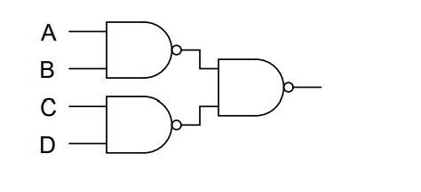

**Answer:**

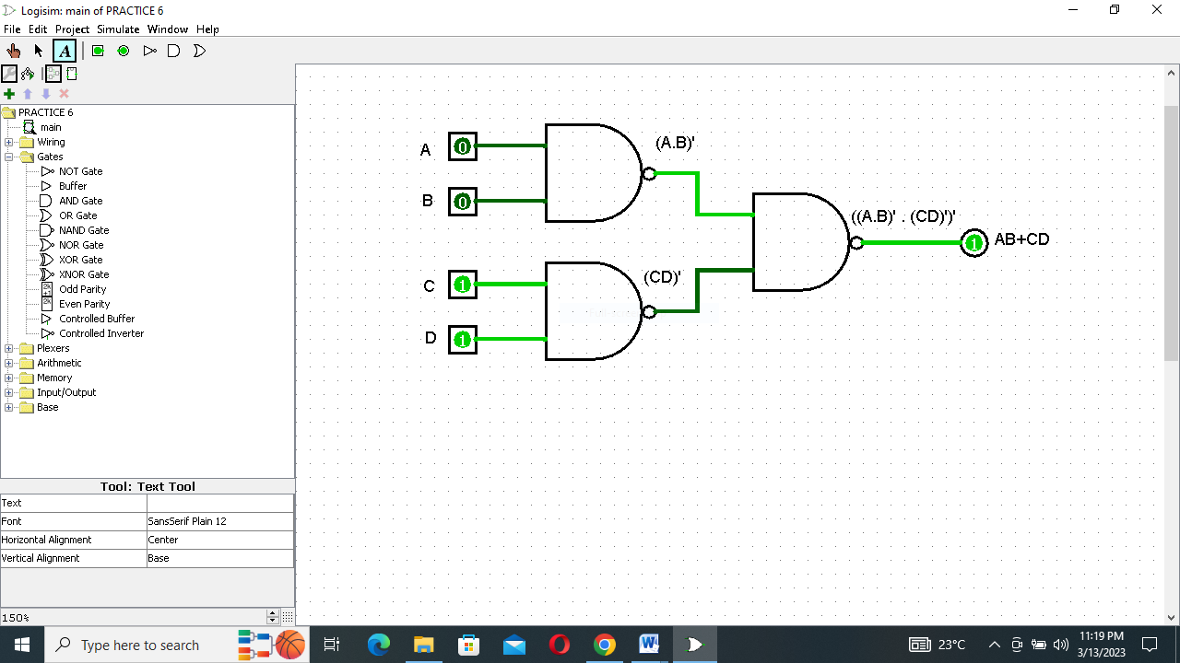

First gate= (A.B)’

Second gate=(C.D)’

Third gate =((A.B)’.(C.D)’)’ Using De-morgans Law

(A.B)’=A’ + B’

= ((A.B)’)’ + ((C.D)’)’ Using Involution Law.

(A’)’=A

= (A.B) +(C.D)

Q:4 Apply the principles of DE Morgan’s theorems to the simplification of a gate circuit:

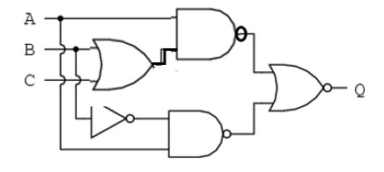

Solution:

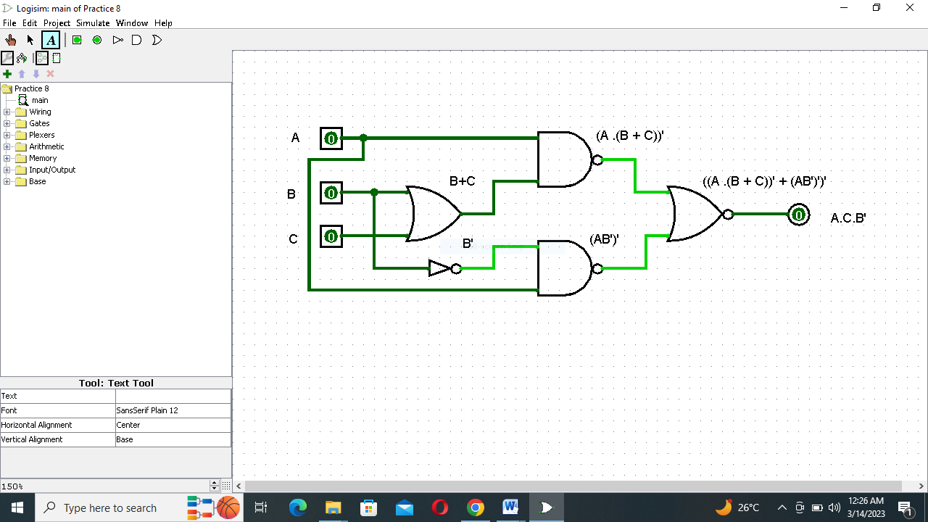

First gate= B+C

Second gate =(A . (B + C))’

Third gate= (A.B’)’

Fourth gate= ((A . (B + C))’ + (A.B’)’)’

Using De-morgans Law

: -A’+B’=A’ . B’

= ((A.(B+C))’)’ . ((A.B’)’)’

Using Involution law

:- (A’)’=A

= A.(B+C) . (A.B’)

= (A.B +A.C) . (A.B’)

= ABAB’ + ACAB’

=AABB’ + AACB’ :- AA=A

Using and law:- AA’=A

= 0 + ACB’ :- A +0 =A

=ACB’.

**THE END**